Source Code :(LED Blinking)
void main() {

TRISB = 0x00; // Configure all PORTB pins as output
PORTB = 0x00; // Initially turn OFF all LEDs

while(1)
{
// Turn ON LED at RB0
PORTB.F0 = 1;
PORTB.F1 = 0;
PORTB.F2 = 0;
PORTB.F3 = 0;
Delay_ms(300);

// Turn ON LED at RB1
PORTB.F0 = 0;
PORTB.F1 = 1;
PORTB.F2 = 0;
PORTB.F3 = 0;
Delay_ms(300);

// Turn ON LED at RB2
PORTB.F0 = 0;
PORTB.F1 = 0;
PORTB.F2 = 1;
PORTB.F3 = 0;
Delay_ms(300);

// Turn ON LED at RB3
PORTB.F0 = 0;
PORTB.F1 = 0;
PORTB.F2 = 0;
PORTB.F3 = 1;
Delay_ms(300);
}
}

Circuit diagram:

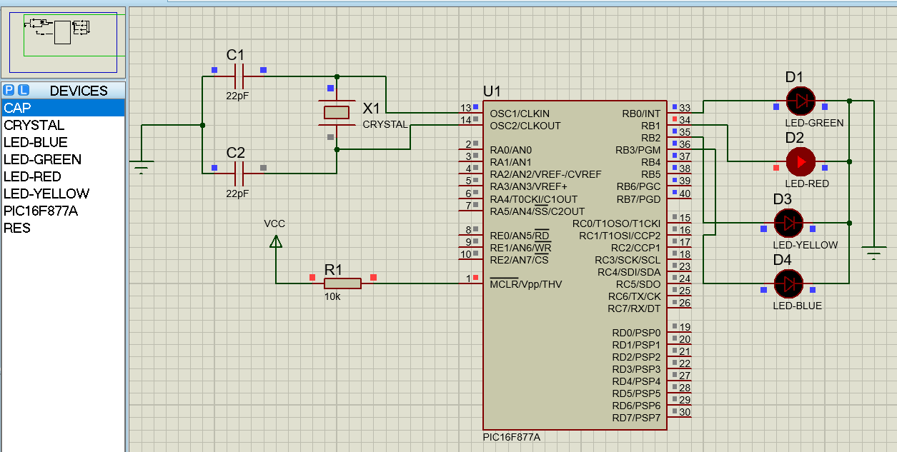
Figure-1: LED flasher using PIC microcontroller.

Source Code :(Seven Segment Display)
char array[]={0x3f, 0x06, 0x5b, 0x4f, 0x66, 0x6d, 0x7d, 0x07, 0x7f, 0x6f};
int i;
void main() {

TRISB=0x00;
portb=0x00;
while(1)
{
for(i=0;i<10;i++)
{
portb=array[i];
delay_ms(1000);
}
}

}

Circuit Diagram:

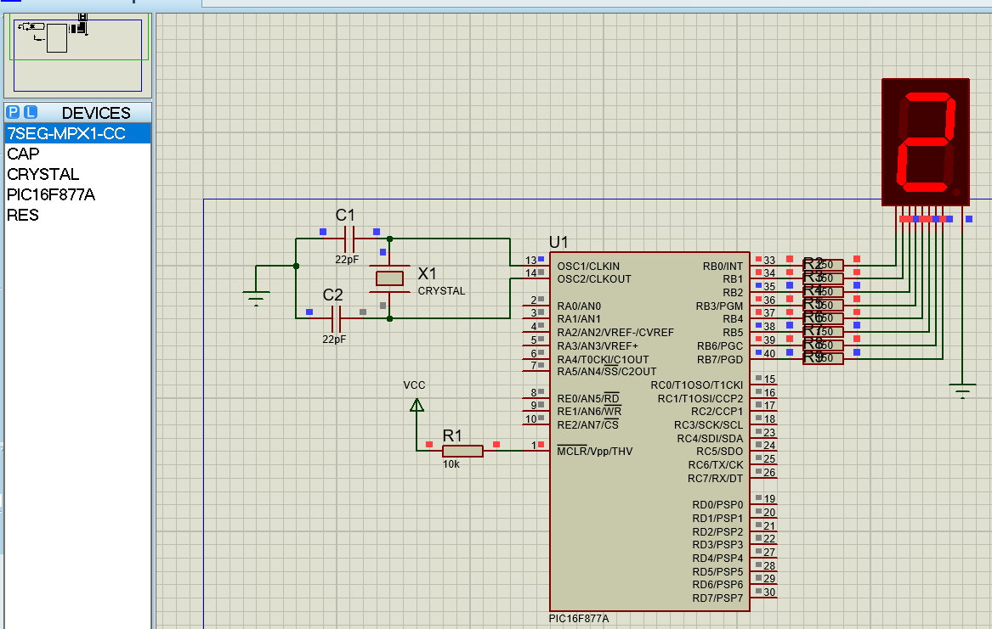
Figure-2: count 0 to 9 in 7 segment display.

Source Code :
char array[]={0x3f, 0x06, 0x5b, 0x4f, 0x66, 0x6d, 0x7d, 0x07, 0x7f, 0x6f};
void main()
{
int i=0;
int j, Left_digit=0, Right_digit=0,count;
TRISB=0x00;
TRISC=0x00;
portb=0x00;
portc=0x00;
while(1)
{
Left_digit=i/10;
Right_digit=i%10;
for(j=0;j<50;j++)
{

portb=array[Left_digit];
portc.f0=0;
delay_ms(10);
portc.f0=1;
portc.f1=0;
portb=array[Right_digit];
delay_ms(10);
portc.f1=1;
}

if(i>99)
i=0;
else
i++;
}
}

Circuit Diagram:
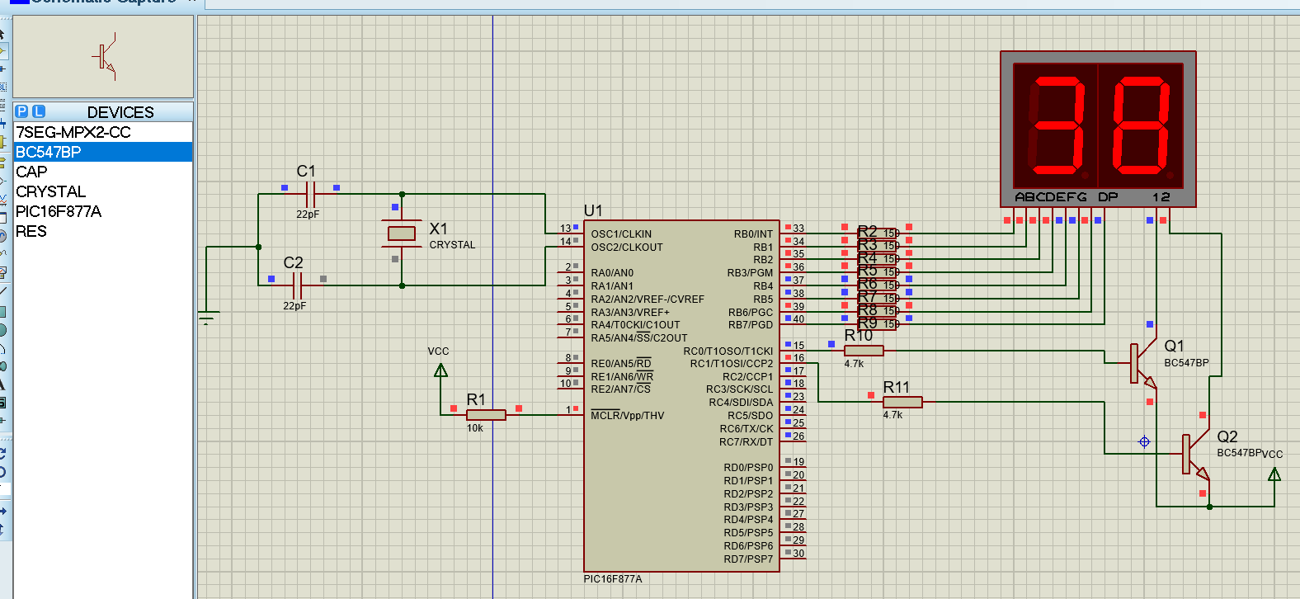
Figure-3:7-segment multiplexer.

Source Code :
char arr[] = {0x40,0x79,0x24,0x30,0x19,0x12,0x02,0x78,0x00,0x10};

void main() {
int count=0,left,right;

TRISB = TRISC = 0x00;
TRISD = 0xff;
PORTB = PORTC = PORTD = 0x00;

while(1){
//increase button
if(PORTD.F0 == 1){
Delay_ms(30); // debounce
if(PORTD.F0 == 1){
count++;
if(count == 100) count = 0;

while(PORTD.F0 == 1); // wait till release
}
}
//descrease button
if(PORTD.F1 == 1){
Delay_ms(30); // debounce
if(PORTD.F1 == 1){
if(count == 0) count = 0;
else count--;
while(PORTD.F1 == 1); // wait till release
}
}

//reset button
if(PORTD.F2 == 1){
delay_ms(30);
if(PORTD.F2 == 1) {
count = 0;
}
}

left = count/10;
right = count%10;

PORTC.F0 = 1;
PORTB = arr[left]; //segment show
Delay_ms(5);
PORTC.F0 = 0;

PORTC.F1 = 1;
PORTB = arr[right];
Delay_ms(5);
PORTC.F1 = 0;
}
}
Circuit Diagram:

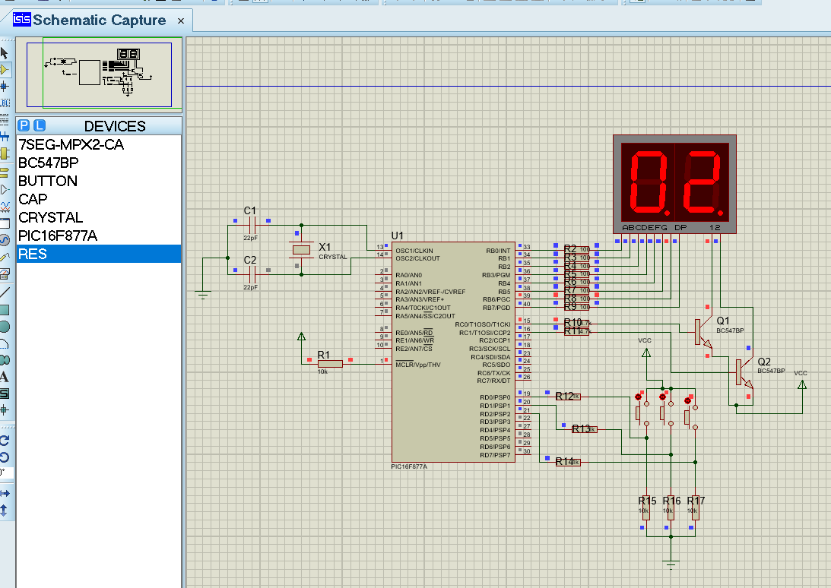
Figure-4: interface double digit 7 segment LED display using push button.

Source Code :
void main() {
TRISB=0x00; //set port b as output
portb=0x00; //initialize as 0
while(1)
{
portb.f0=1;
delay_ms(1000);
portb.f0=0;
delay_ms(1000);
}
}

Circuit Diagram:

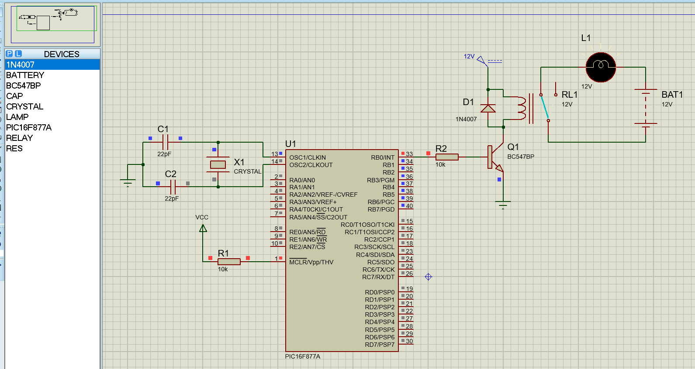
Figure-5: control a high voltage load using mechanical relay.

Source Code :
void main()
{
short duty = 0;

TRISD = 0xFF;
TRISB = 0x00;
TRISC.F2 = 0;

PORTB.F0 = 1;
PORTB.F1 = 0;

PWM1_Init(1000);
PWM1_Start();
PWM1_Set_Duty(0);

while(1)
{
// -- Speed UP (RD0) --
if(PORTD.F0 == 1)
{
Delay_ms(50);
if(PORTD.F0 == 1)
{
if(duty <= 245)
duty += 10;
PWM1_Set_Duty(duty);
while(PORTD.F0 == 1); // wait release
}
}

// -- Speed DOWN (RD1) --
if(PORTD.F1 == 1) // ? PORTD.F1 explicitly
{
Delay_ms(50);
if(PORTD.F1 == 1)
{
if(duty > 0) // ? duty > 0 check
duty -= 10;
else
duty = 0; // ? ???? negative ??? ??
PWM1_Set_Duty(duty);
while(PORTD.F1 == 1); // wait release
}
}
}
}

Circuit Diagram:
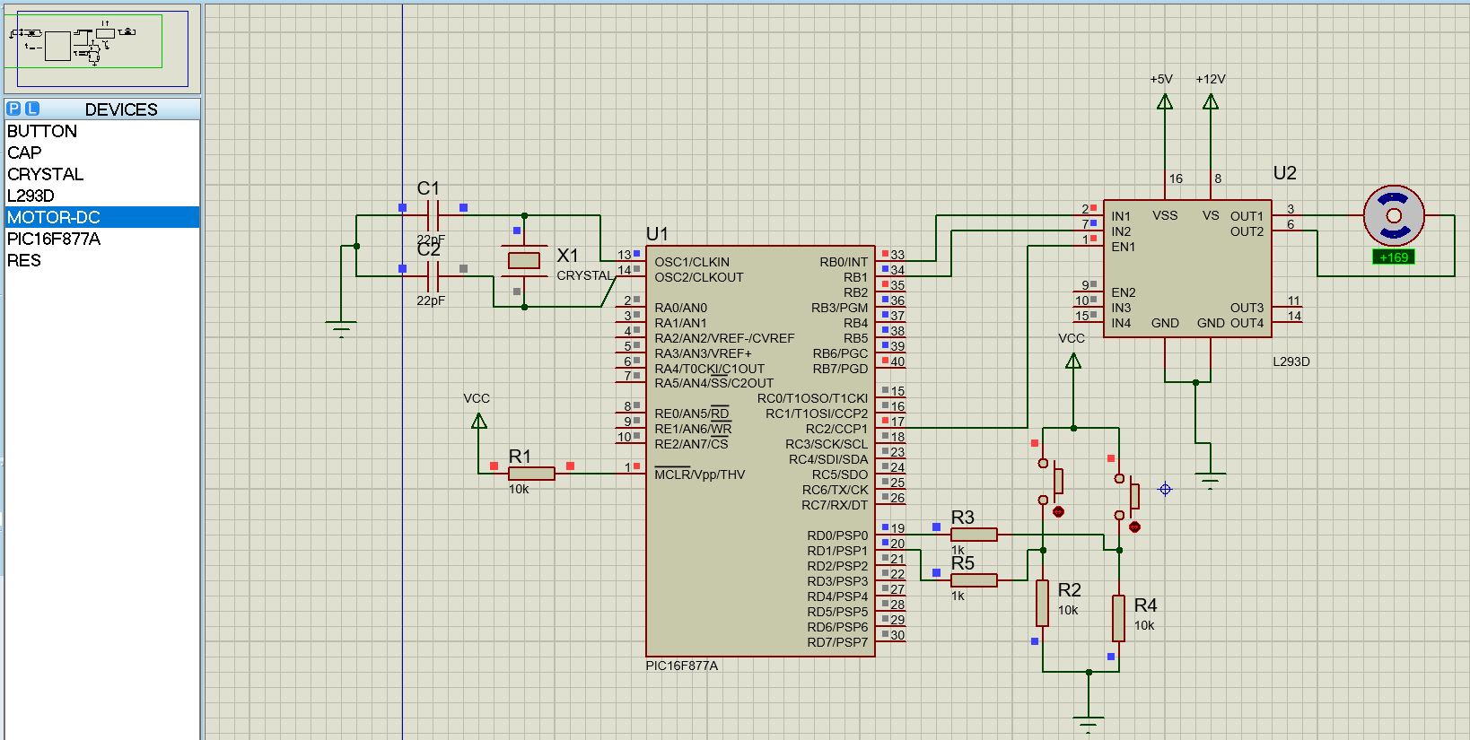
Figure-6: DC motor speed using PIC microcontroller

Source Code :
int i;

void main() {

TRISB.F0 = 0; // RB0 output
PORTB.F0 = 0;

while(1){

// 0 degree
for(i=0; i<50; i++){
PORTB.F0 = 1;
Delay_us(1000); // 1 ms pulse
PORTB.F0 = 0;
Delay_us(19000); // total 20 ms
}
Delay_ms(500);

// 90 degree
for(i=0; i<50; i++){
PORTB.F0 = 1;
Delay_us(1500); // 1.5 ms pulse
PORTB.F0 = 0;
Delay_us(18500);
}
Delay_ms(500);

// 180 degree
for(i=0; i<50; i++){
PORTB.F0 = 1;
Delay_us(2000); // 2 ms pulse
PORTB.F0 = 0;
Delay_us(18000);
}
Delay_ms(500);
}
}

Circuit Diagram:
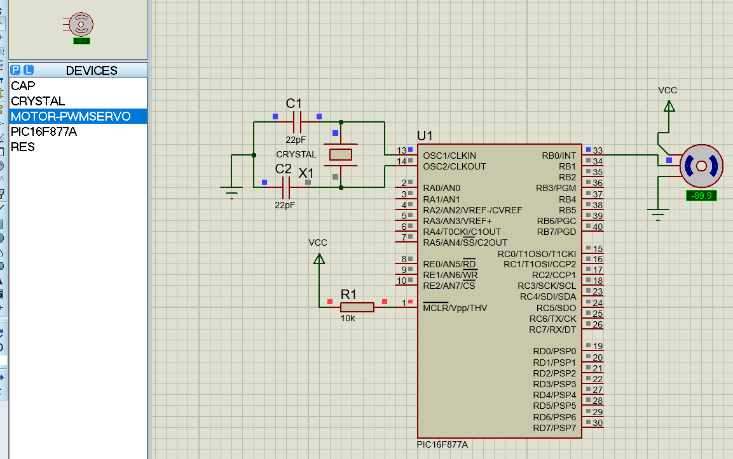
Figure-7: Servo motor using PIC microcontroller

Source Code :

unsigned int adc_value;
char txt[7];
void main() {
ADCON1 = 0x80; // AN0 analog
TRISA = 0xFF; // PORTA input (AN0 input)
TRISC = 0x80; // RC7 input, RC6 output
UART1_Init(9600); // UART 9600 baud
Delay_ms(100);
while(1)
{
adc_value = ADC_Read(0);
IntToStr(adc_value, txt); // Integer ? String
UART1_Write_Text("ADC Value = ");
UART1_Write_Text(txt);
UART1_Write(13); // Carriage return
UART1_Write(10); // New line
Delay_ms(500);
}
}

Circuit Diagram:(ADC)
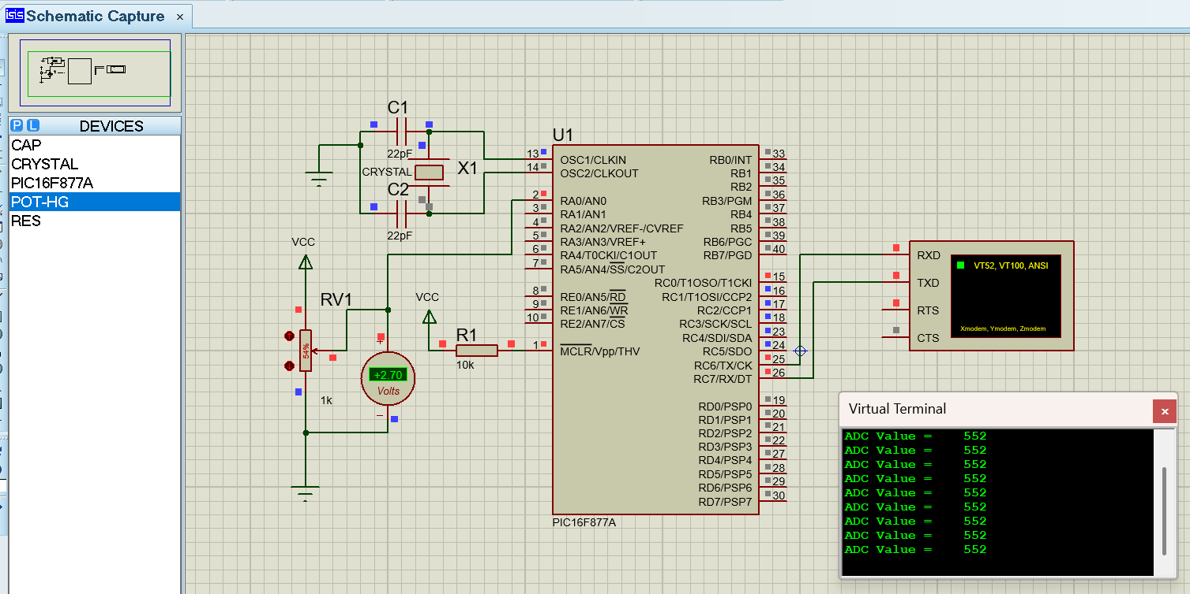
Figure-8: Analog to Digital (ADC) conversion feature of PIC microcontroller.

Source Code :

// LCD module connections
sbit LCD_RS at RB0_bit;
sbit LCD_EN at RB1_bit;
sbit LCD_D4 at RB2_bit;
sbit LCD_D5 at RB3_bit;
sbit LCD_D6 at RB4_bit;
sbit LCD_D7 at RB5_bit;

sbit LCD_RS_Direction at TRISB0_bit;
sbit LCD_EN_Direction at TRISB1_bit;
sbit LCD_D4_Direction at TRISB2_bit;
sbit LCD_D5_Direction at TRISB3_bit;
sbit LCD_D6_Direction at TRISB4_bit;
sbit LCD_D7_Direction at TRISB5_bit;
// End LCD module connections

char txt1[] = "Information & Communication Engineering";
char txt2[] = "ICE(PUST)";

char i; // Loop variable

void Move_Delay() { // Function used for text moving
Delay_ms(300); // You can change the moving speed here
}

void main(){
ADCON1 = 0x06; // Configure AN pins as digital I/O
CMCON = 0x07;

Lcd_Init();
Lcd_Cmd(_LCD_CLEAR);
Lcd_Cmd(_LCD_CURSOR_OFF);

Lcd_Out(1,1,txt1);
Lcd_Out(2,5,txt2);

Delay_ms(1000);

while(1) { // Endless loop
for(i=0; i<24; i++) {
Lcd_Cmd(_LCD_SHIFT_LEFT);
Move_Delay();
}

/* for(i=0; i<8; i++) { // Move text to the right 7 times
Lcd_Cmd(_LCD_SHIFT_RIGHT);
Move_Delay();
} */
}
}

Circuit Diagram:(LCD)
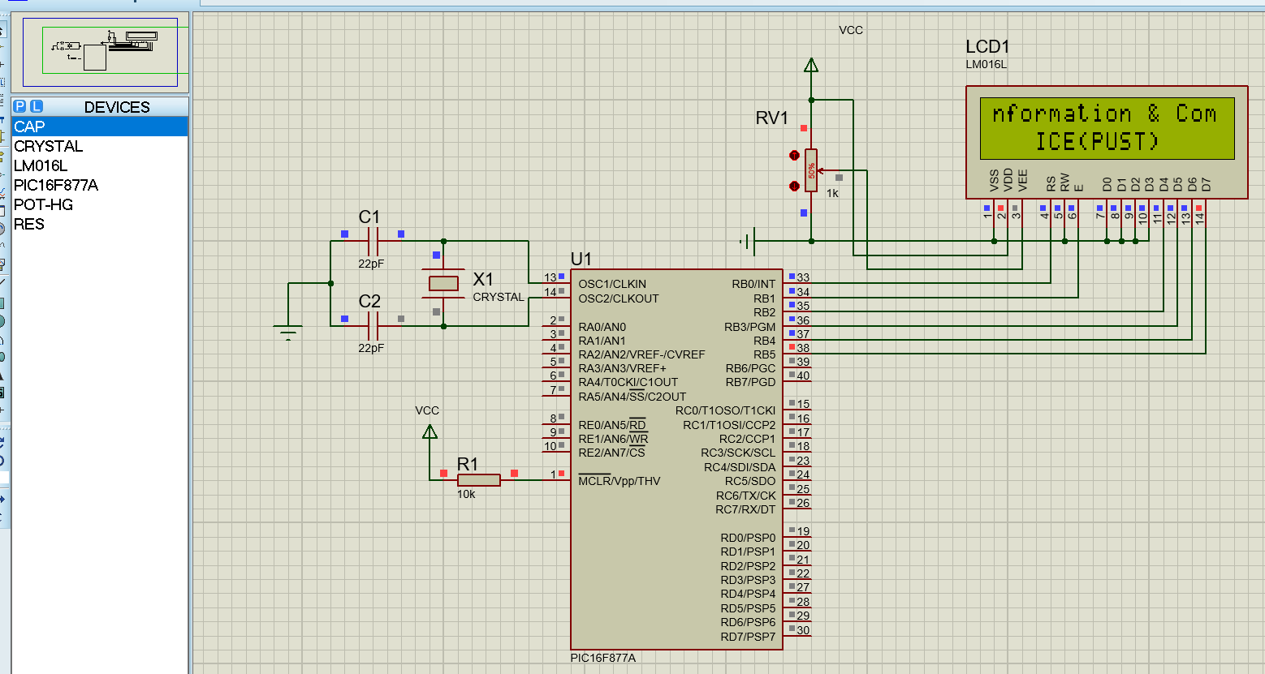
Figure-9: Interface and Display Data on LCD using PIC Microcontroller.

Source Code :
// LCD module connections
sbit LCD_RS at RB0_bit;
sbit LCD_EN at RB1_bit;
sbit LCD_D4 at RB2_bit;
sbit LCD_D5 at RB3_bit;
sbit LCD_D6 at RB4_bit;
sbit LCD_D7 at RB5_bit;
sbit LCD_RS_Direction at TRISB0_bit;
sbit LCD_EN_Direction at TRISB1_bit;

sbit LCD_D4_Direction at TRISB2_bit;
sbit LCD_D5_Direction at TRISB3_bit;
sbit LCD_D6_Direction at TRISB4_bit;
sbit LCD_D7_Direction at TRISB5_bit;
// End LCD module connections
char display[16]="";
void main()
{
unsigned int result;
float volt,temp;
trisb=0x00;
trisa=0xff;
adcon1=0x80;
lcd_init();
lcd_cmd(_lcd_clear);
lcd_cmd(_LCD_CURSOR_OFF);
while(1)
{
result=adc_read(0);
volt=result*4.88;
temp=volt/10;
lcd_out(1,1,"Temp = ");
floattostr(temp,display);
lcd_out_cp(display);
lcd_chr(1,16,223); //print at pos(row=1,col=13) "°" =223 =0xdf
lcd_out_cp(" C"); //celcius
}
}

Circuit Diagram:(Temperature sensor)
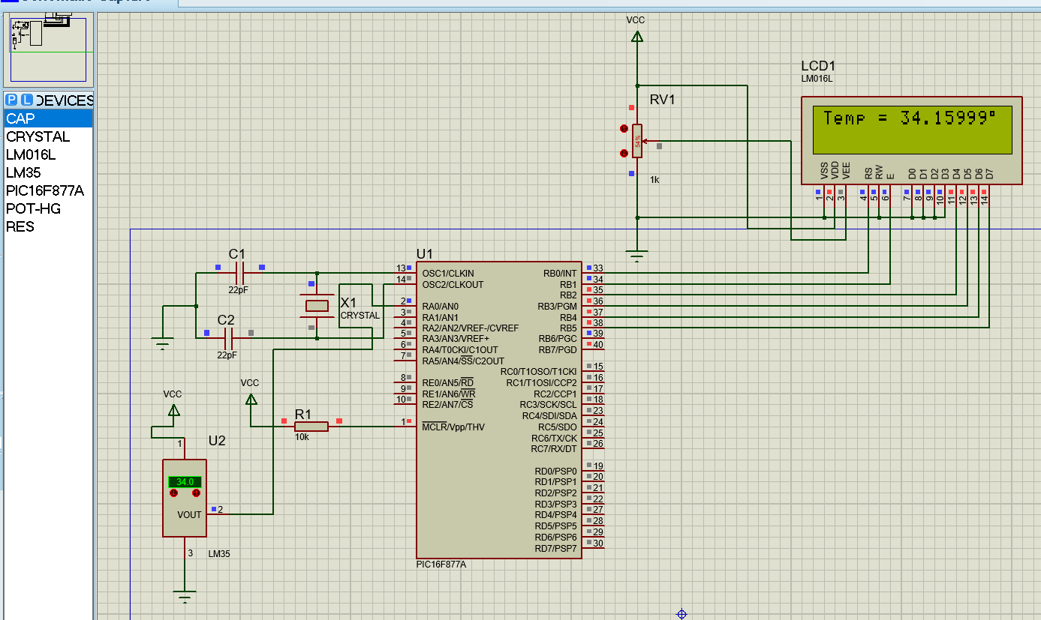
Figure-10: sensor input from LM35 temperature sensor and display corresponding sensor value through LCD display.

Source Code :
void main()
{
TRISD = 0x00;
PORTD = 0x00;
do
{
PORTD = 0b00000011;
Delay_ms(500);
PORTD = 0b00000110;
Delay_ms(500);
PORTD = 0b00001100;
Delay_ms(500);
PORTD = 0b00001001;
Delay_ms(500);
} while(1);
}

Circuit Diagram:(Stepper Motor)
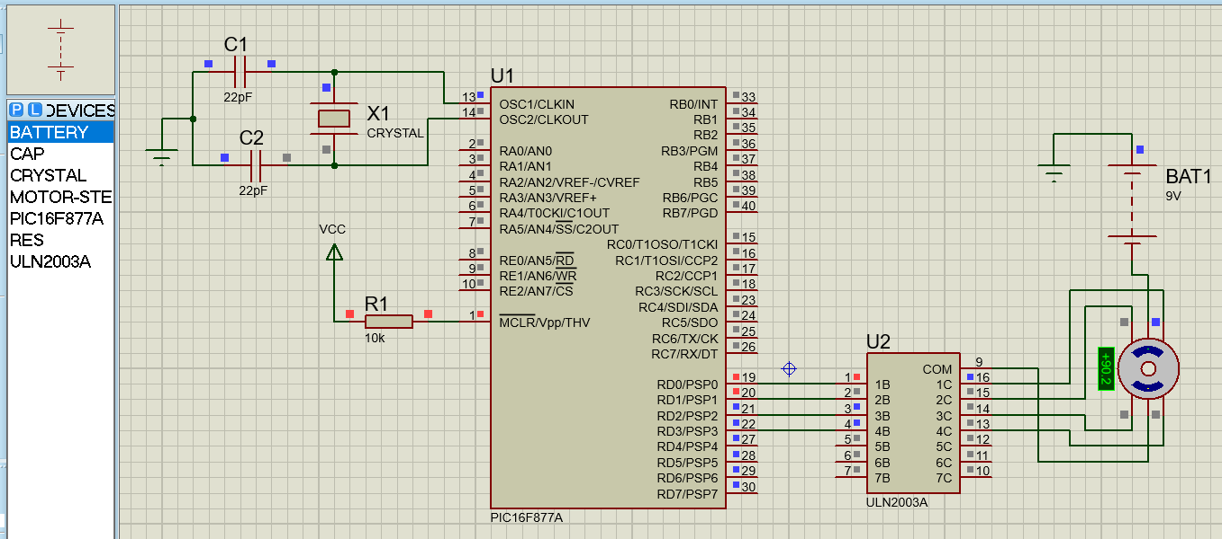
Figure-11: Stepper motor using PIC microcontroller.

Source Code :
unsigned char count;
unsigned char seg[] = {0x3F,0x06,0x5B,0x4F,0x66,0x6D,0x7D,0x07,0x7F,0x6F};
void main(){
ADCON1 = 0x06;
TRISB = 0x00;
count = EEPROM_Read(0x00);
if(count > 9) count = 0;
while(1){
PORTB = seg[count];
Delay_ms(1000);
count++;
if(count > 9) count = 0;
EEPROM_Write(0x00, count);
Delay_ms(20);
}
}

Circuit Diagram:(EEPROM)
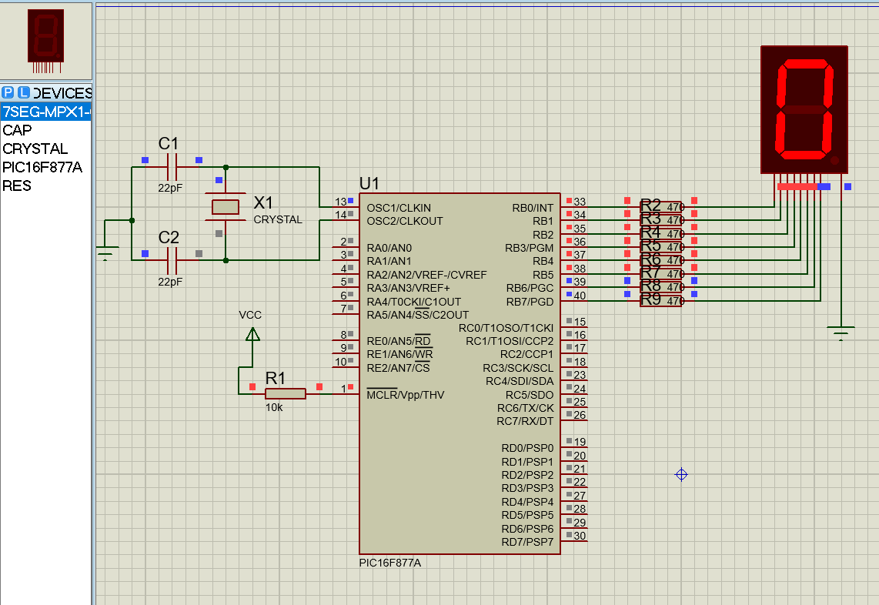
Figure-12: Interface EEPROM for Data Storage and Retrieval using PIC Microcontroller

Source Code :
void MSDelay(unsigned char Time){
unsigned char y,z;
for(y=0x00; y<Time; y++)
for(z=0x00; z<0x14; z++);}
void main(){
TRISC = 0x00;
TRISD = 0x00;
while(0x01) {
PORTD = 0x80;
PORTC = 0xFF;
MSDelay(0x0A);
PORTD = 0x40;
PORTC = 0xFF;
MSDelay(0x0A);
PORTD = 0x20;
PORTC = 0x3C;
MSDelay(0x0A);
PORTD = 0x10;
PORTC = 0x66;
MSDelay(0x0A);
PORTD = 0x08;
PORTC = 0xC3;
MSDelay(0x0A);
PORTD = 0x04;
PORTC = 0x81;
MSDelay(0x0A);
PORTD = 0x02;
PORTC = 0x00;
MSDelay(0x0A);
PORTD = 0x01;
PORTC = 0x00;
MSDelay(0x0A); }}

Circuit Diagram:(Dot Matrix Display)
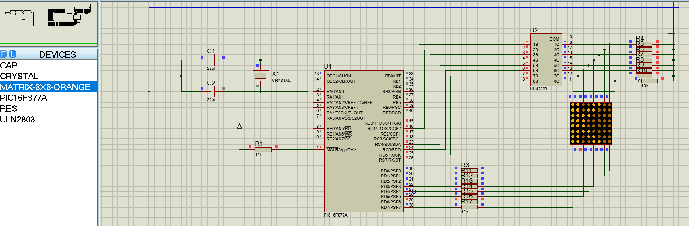

Figure-13: display character through dot matrix display.
